Manch Aur Maanavta

**Theatre for Social Action and Truth**

**19-23 December, 2013**

[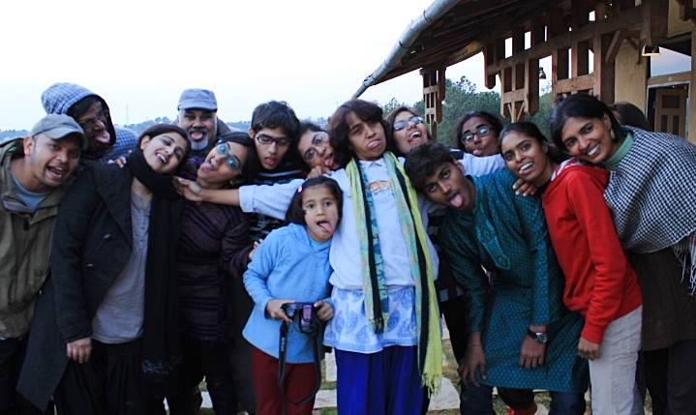](http://www.sambhaavnaa.org/wp-content/uploads/2013/10/995575_702229189811220_29981698_n.jpg)

**Background**

Change in society happens with the confluence of two complementary processes: on the one hand, it requires the creation of new social structures and institutions, influencing public policy and socio-political mobilisation; and on the other hand, it needs a transformation in the way people think, in their ideas and worldviews. While many forms of social action focus on the former, theatre is a medium that bridges the gap between both these processes.

Engagement with theatre not only helps the social activist delve deeper into their own worldview and perspectives, but also acts as an important tool for social mobilisation and reaching out to people and communities. ‘Being the Change’ leads to acting the change in one’s life and further action for change, in society.

Theatre has played a significant role in the processes of transformative politics across the world: from the plays of Bertolt Brecht in Germany, to the ‘Theatre of the Oppressed’ in Brazil and the street theatre of Safdar Hashmi and Jan Natya Manch in India. It is a medium that can foster critical thinking, encourage the process of analyzing rather than accepting, ‘acting’ rather than just talking, of connecting the individual to the collective. The evocative language of theatre can give a voice to the voiceless and be an empowering medium for socially marginalised communities.

**About the Resource Person**

The workshop anchored by Jaya Iyer at Sambhaavnaa Institute was designed for social activists and those interested in change through theatre.

For the last eighteen years, Jaya has been working in the field of development theatre and social education. Trained in participatory theatre skills, she has designed and trained field workers, teachers, activists and young people in India and abroad. She has been associated with Pravah, a non-profit organization working with young people for a decade and was its CEO for three years.

**The Participants**

20 participants from different states and professional backgrounds participated in the workshop. Half of the participants were women. The common interest was theatre and some of the participants were already from a background where drama and theatre was being used by them.

**The Key Activities**

**A Broad Outline of the space created during the workshop**

A space to relax, be silent, scream , dance , jump, sleep, confront, work hard, sweat, listen, challenge ,heal, connect and love, to work on self, silently and together help others to see and in that process glimpse , a safe space to be naked and not to be threatening, threatened, non judgmental and open, creative and fun. A space to be …and a space to do…

Dance and rhythm, theatre of the oppressed, contemplative practices as well as real life engagements.

Connecting the self to the social , individual to the universal

Love and legislation, respect traditions and work to reform

**Methods and Processes**

**Game playing and group exercises are** the core of Theatre of the Oppressed. An extensive arsenal of well crafted and expertly facilitated games were transacted which allows participants to stretch the limits of their imaginations, demechanize habitual behaviors and deconstruct and analyze societal structures of power and oppression. Plus, game playing is fun and builds community!

The processes and games played during the workshop included:

* Defining conflict, violence and freedom – concept clarity in groups
* Columbian Hypnosis for Trust building
* The Statue game for team work, trust building, body image and space
* Morning exercises – the ABC of using body space for connecting to the body and opening up the body
* Maya Bazaar for Self Exploration
* Emotional vocabulary for connecting to the inner spaces and finding ways to express these

**Through Image Theatre** participants explored issues of oppression by using nonverbal expression and sculpting their own and other participants’ bodies into static physical images that can depict anything concrete or abstract, such as a feeling, issue, or moment.

The processes and games played during the workshop included:

* Ramayan Potrayal – to decipher how images work
* Image theatre for feedback on workshop

**Forum Theatre** is a performance that functions to transform from spectator (one who watches) to a spectator (one who watches and takes action). A short scene by Forum actors presents an issue of oppression and represents the world as it is–the anti-model. Audience members are then encouraged to stop the play and take the stage to address the oppression, attempting to change the outcome through action. The show engages Forum actors and audience members in fun, entertaining and enlightening community dialogue.

[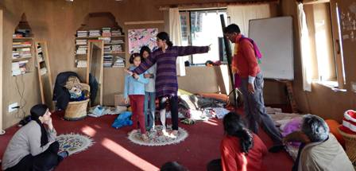](http://www.sambhaavnaa.org/wp-content/uploads/2013/10/1602104_702228523144620_1534210724_o01.jpg)

Day wise introduction to Forum Theatre:

Day 1 and 2 : scripting and social stories – creating a play

Day 3 : practicing , sharpening the performance

Day 4 : performance

Day 5 : evaluation -making sense of the responses

[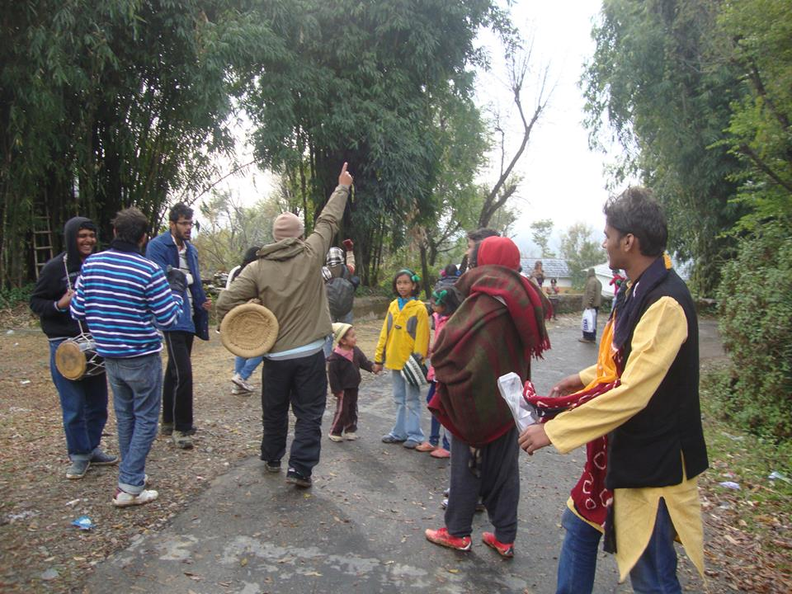](http://www.sambhaavnaa.org/wp-content/uploads/2013/10/61430_702260146474791_620888981_n.jpg)

Participants were divided into three groups and themes were chosen for creating a Forum Theatre by each group. The themes included:

* Discrimination against the Girl Child
* Land grab and exploitation within the family
* River bed mining and exploitation by mafia

[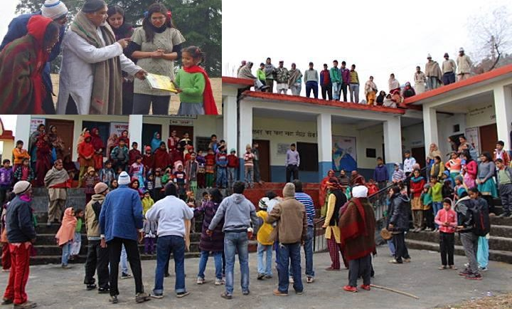](http://www.sambhaavnaa.org/wp-content/uploads/2013/10/1545035_702229066477899_1683546510_n-mam.jpg)

The three key elements/stages in Forum include:

* Setting the Context: The context of oppression is described by creating a situation
* Bringing out the Conflict: Between the opressor the and the oppressed
* Climax – The final image of the oppressor and oppressed in
* Jokering and participation from the audience: Dialogue with the audience through non-violent communication

**Participants’ Feedback**

1. Most of the participants found the workshop useful because of its holistic approach of experiential learning. In particular, the practice and real life forum theatre performed in Kandwari and Nanahar which was the central component of the program because it dealt with the transformative process with the involvement of the audience – the local people, was enjoyed by al
2. The interactive nature of the program and the various group exercises for concept clarity in a collective way were much appreciated
3. The space for self-exploration – both physical and mental/spiritual was a critical component of the workshop and helped many participants in their personal shifts and changes.

Participant list:

|  |  |
| --- | --- |
| **Name** | **Area of Work** |
| Abhishek Gupta | Student IIT Delhi |
| Ayush | Theatre Artist |
| Mohit Mehta | Student of  Bits Pilani  Hyderabad Campus |
| ChitraUpadhayay | Science student and Volunteer  of Sambhaavnaa |
| Robin Chaurasiya | Founder of Kranti Organization |
| Ankita Anand | Theatre Artist of Aatish |
| Arjun Aiyer | Student of Swaraj University |
| Nachiketa Doctor | Student of Swaraj University |
| Charu Mehta | Student of IIT Delhi |
| Rajeev srivastava ashish | Theatre Artist |
| Ashok Gogia | Freelance Maths Teacher |
| Sukriti Khurana | Theatre Artist |
| Sachin Jadhav | Theatre Artist and student of Shikshanter |
| Sumit mahar | Volunteer of himdhara |
| Anita Mahato | Theatre Artist |
| Shrikant Chitlangya | Social activities in rural areas |
| Manshi Asher | Social activities in rural areas |
| Sandhya Gupta | Sambhaavnaa GB Member |
| Ira Saxena | Sambhaavnaa Program manager |
| Gauri | Student |
| Shamli | Student |